MyHousing Landlord Portal

Frequently Asked Questions (FAQs)

1. What is Landlord Portal
Landlord Portal is a new online tool that allows landlords with tenants with the Lowell Housing Authority to review information pertaining to your issued payments, tenants, scheduled and completed inspections, and tax forms at your convenience, without having to call or visit the Housing Authority office.

Landlord Portal is located at: https://lhma.myhousing.com/account/login

2. How do I register/create a new account?
You MUST FIRST Register before you can access the site, to register you will need your tax id and an active email address. To register click https://lhma.myhousing.com/account/login

3. Who can register?
Only active landlords who are receiving Housing Assistance Payments (HAP) with Lowell Housing Authority can create new accounts.

4. How is Landlord Portal useful to me as a landlord?
As a registered landlord, you will be able to use Landlord Portal to review
- Your profile
- A list of your EHV and/or HCV tenants
- Your HAP payments, by tenant, for the prior 24 months
- Reexamination or recertification dates for your tenant(s)
- Year-end tax forms

Additionally, you will be able to access and view:
- Upcoming Housing Quality Standard (HQS) inspections
- View and download Inspection reports

- What do I do if I can’t remember my username/password, or I want to change my password?
If you need to recover your username and/or password, you can do so https://lhma.myhousing.com/account/login or by selecting the “Forgot Password” on the portal login. If you need additional help, you can contact us at 978-364-5311.

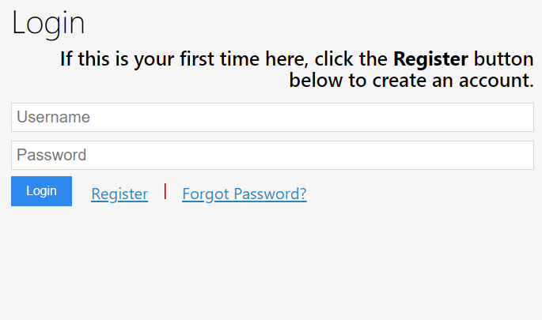

6. How can I find information about my HAP payments?
Log in first, and then click on the "Landlord Portal" link to the left. Select the action button entitled “My Payments”.
Clicking on the View Details button will provide you with detailed payment information.
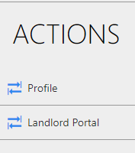
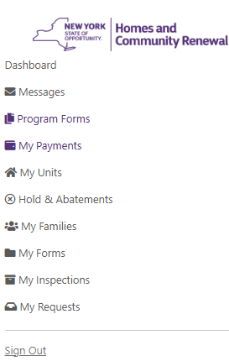

7. How can I find information about my rented units?
Log in first, and then click on the "Landlord Portal" link to the left. Select the action button entitled “My Units”.
Clicking on the View Details button will provide you with additional information such as Resident and Unit Demographics.

8. How can I find information about my tenant’s payment holds or abatements?
Log in first, and then click on the "Landlord Portal" link to the left. Select the action button entitled “Holds and Abatements”.
The list can be sorted by unit address, type (Unit or Abatement) or status (Open or Closed) by clicking on the down arrow of the drop-down menus.

9. How can I find information about my tenants?
Log in first, and then click on the "Landlord Portal" link to the left. Select the action button entitled “My Families”.
Clicking on the View Details button will provide you with additional information, such as the assigned Caseworker.

11. What inspection information is available in Landlord Portal?
With Landlord Portal, you can view both Historical and Upcoming inspections.
Log in first and click on the "Landlord Portal" link to the left. Select the action button entitled “My Inspections”.
Select Historical Inspections to view past inspections. To download the Inspections report, select the “Download Results” link.
To view scheduled Upcoming inspections, select “Upcoming Inspections”.
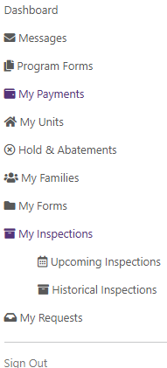

12. Can I access my 1099 or 1042 documents?
Yes. You can view/print current and historical 1099 or 1042 documents.
Log in first and click on the "Landlord Portal" link to the left. Select the action button entitled “My Forms”.
Click 1099 or 1042 to retrieve the selected tax document and a new window will appear. Select the tax form NESC or MISC.
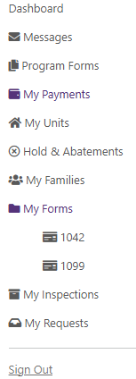

13. How can I review my own profile information?
Log in first, and then click on the "My Profile" link to the left. You will see general contact information associated with your user profile on Landlord Portal. For your protection, changes to your information cannot be made online.

14. Some of my tenants are missing. Why can’t I see all of them?
This occurs if you are a Management Company or a landlord with multiple properties. To link you to all your properties please email us at apurtell@lhma.org so we may assist you.

15. I have other questions. Who can I contact for support?
For Landlord Portal support, you may email your questions to: apurtell@lhma.org

